Name ____________________________________________ Period ________
1 | rock - feather - boat nail  - ping pong ball marble anchor - ice cube
2 | 2000 g/cm³ 800 g/cm³ - 8 g/cm³ 0.125 g/cm³
3 | - oxygen - copper water - potassium salt sugar
4 | - an element - a compound a mixture
5 | a cup of tea |  |  | a glass of orange juice with no pulp
 | a glass of milk |  |  | - a glass of carbonated soda with ice and a straw
6 | The air in our environment that is made up of nitrogen and oxygen.
 | A piece of jewelry that is made up of silver and gold.
 | A pan of salt water on the stove BEFORE you add the pasta.
 | - An ice cream sundae with whipped cream, nuts, and a cherry.
7 | chocolate chip cookie - sugar cookie - Hershey’s chocolate bar Reese’s peanut butter cup Snickers Bar
8 | Use a pair of tweezers to gather the nails. |  | Use scotch tape to gather the nails.
 | - Use a magnet to gather the nails. |  | Use a leaf blower to move just the sawdust and leave the nails.
9 | would stay dissolved in the water when it turns to steam. |  |  |  | cannot be separated from the water.
 | - end up as a crystalline solid after the water boiled off.
10 | the elements hydrogen and oxygen. | water and air. |  |  |  | different each time the experiment was run.

Classification of Matter Activity

We classify matter into several categories such as elements, mixtures, compounds, etc. In column 1, write the definition from your textbook. In column 2, rewrite the definition in your own words. Simplify the definition. In column 3 draw a picture or graphic that will help you remember each of the terms.

Chapter Definition | Your Definition | Graphic Reminder
Substance:

Mixture:
Element:
Compound:
Heterogeneous Mixture:
Homogeneous Mixture:
On the lab tables you will see 12 different samples of matter that need to be classified. Your job is to classify each of the 12 samples of matter. First decide whether each type of matter is a “pure substance” or a “mixture” in column 1. If you decide “substance” then in column two you decide between “compound/element” in column 2. If you decide “mixture” in column 1, then you choose between “homogeneous/heterogeneous” in column 2. BE CAREFUL TO NOT MIX-UP THE OPTIONS! When you have decided, be sure you explain your choices in column 3.

 | Substance or Mixture | Compound/Element or Homogeneous/Heterogeneous | Explain your choices!
#1 | Substance | Cmpd | Pure NaCl
#2 | Substance | Element | Fe filings
#3 | Substance | element | Sulfur powder – feel free to briefly open if you want to show S has no odor – MAKE SURE IT IS PROPERLY RESEALED
#4 | Mixture | Hetero. Mix | Fe + S mixed in vial
#5 | Mixture | Homo. Mix | Tap water
#6 | Substance | Element | Cu
#7 | Mixture | Homo mix | Store bought NaCl is iodized
#8 | Mixture | Hetero mix | Water + oil
#9 | Substance | Cmpd*** | Nut/bolts are joined, making it a cmpd
#10 | Mixture | Hetero mix*** | Separated nut/bolts makes it a mixture; uneven #’s is hetero
#11 | Substance | Cmpd | Pure water
#12 | Mixture | Homo mix*** | vaseline

*** denotes the harder of the 12 samples

Name ____________________________ Period _____
Assessment – Separation of Mixtures (each answer blank is 1 point – 35 points total)
Vocabulary Matching
d____1. A mixture in which there are differences in the composition throughout the  substance (jello with fruit). |  | a) elements
c____2. A mixture with a uniform composition throughout (jello). |  | b) compound
a____3. There are 118 of these found on the periodic table. |  | c) homogeneous
b____4. A combination of elements that can only be separated by chemical reactions. |  | d) heterogeneous
e____5. A combination of substances that can be separated without changing the  identity of any of the components. |  | e) mixture
f____6. A sample that contains a single element or a single compound. |  | f) pure substance

c____7. Select the list which contains only elements.
a) copper, carbon, water, and dust
b) sodium, chlorine, air, and lead
c) hydrogen, copper, oxygen, and neon
d) aluminum, helium, wood, and mercury
a____8. A silver chloride precipitate forms when silver nitrate and sodium chloride are mixed. How would the precipitate be recovered?
a) filter the products and dry the filter paper to recover the solid
b) remove the solid from the container with an eye dropper and then dry it
c) use a magnet to separate the product components
d) It is not possible to separate the products.

b____9. Electrolysis is a process that will separate a compound into its elemental components. Water samples are gathered from the classroom sink, a local stream, a bottled-water from the vending machine. Each of these samples is separated into hydrogen and oxygen using electrolysis.
a) The water sample from the stream would have more oxygen because that sample has been open to the air.
b) All three water samples would produce hydrogen and oxygen in a 2:1 mole ratio.
c) The bottled-water would give the best results because that water was purchased.
d) The water from the sink would not separate into hydrogen and oxygen.

a____10. Which of the following substances is not a compound?
a) air (approximately 20% oxygen and 80% nitrogen) b) water (11% hydrogen and 89% oxygen)
c) table salt d) carbon dioxide

d____11. Which of the following is a homogenous mixture?
a) chocolate chip cookies b) ice cream sundae with hot fudge, nuts, and a cherry
c) tossed salad d) a sample of chlorinated pool water

b____12. A chef has a sample of cooking oil that he thinks is olive oil. The density of olive oil is 0.91 - 0.93 g/mL. You measure the mass of 1.0 mL to be 0.85 g. Do you think the sample is oil olive?

a) Yes, the densities are the same, so the substances are the same.
b) No, the sample density is 0.85 g/mL which does not match olive oil.
c) Yes, the density of the sample is lower than olive oil’s density.
d) No, density cannot be used to check if the sample is olive oil.

d___13. The mass and volume of five samples of plastic were measured in lab. The data was used to make the graph shown. Using the provided graph, calculate the density of the plastic in g/cm³?
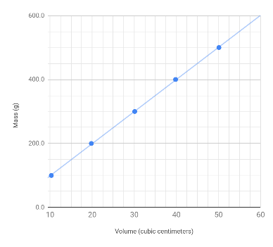

a) 100 g/cm³ b) 50 g/cm³ c) 20 g/cm³ d) 10 g/cm³

Use this space to show your calculation for the density of the plastic:

Students should show their work in finding the slope of this graph in this space.

14. (14 points) You will make TWO X’s in each row. Select “pure substance” or “mixture” by placing an “X” in one of the first two grayed columns. Then, classify each substance as an element, a compound, a homogeneous mixture, or a heterogeneous by placing an “X” in one of the four columns to the right (no fill color). An example is completed for you.
Substance | Pure Substance | Mixture |  | Element | Compound | Homogeneous Mixture | Heterogeneous Mixture
Carbon dioxide | X |  |  |  | X
Pure NaCl | X |  |  |  | X
Tap water |  | X |  |  |  | X
Water and oil |  | X |  |  |  |  | X
Salt and pepper |  | X |  |  |  | X
Pure water | X |  |  |  | X
Vegetable soup |  | X |  |  |  |  | X
Copper | X |  |  | X

15. Complete the flowchart used to classify matter by selecting the correct term to fill-in the four lettered blanks labeled A, B, C and D. (4 points)
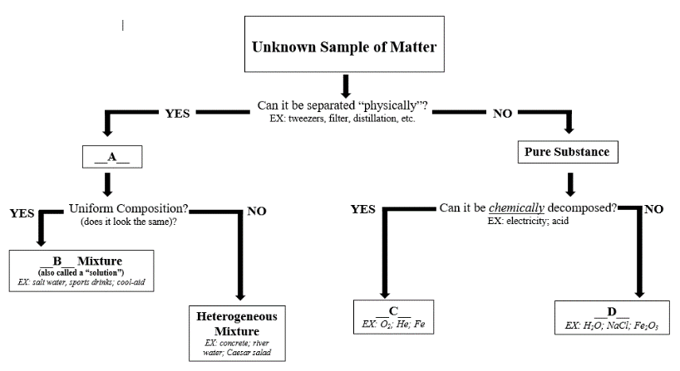

C____ element D____ compound B____ homogeneous A____ mixture

16. (4 points) You are given a container with a mixture of four common substances - sand, salt, small pieces of Styrofoam, and aluminum paper clips. Write a procedure (a numbered list of steps) to separate this mixture into the four components. For each of the four substances, make sure to include whether the substance is an element or a compound.

